**Name: P.Sesha Harshini**

**USN: 1NT19IS107**

**Batch: C1**

Date:05-04-2022

To check if Mongodb is installed or not and version:

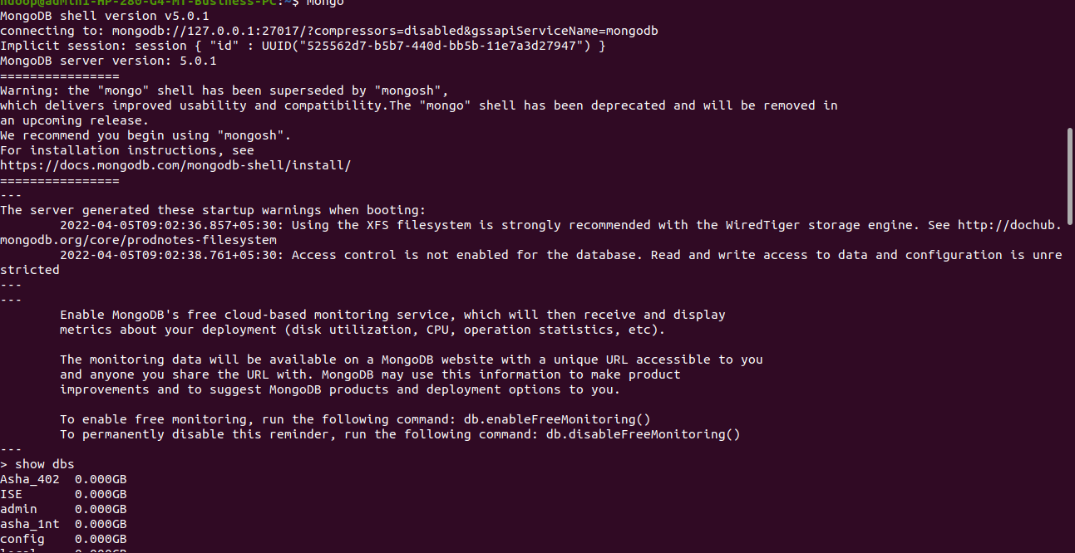

To start mongodb:

mongo

To check the databases present :

show dbs

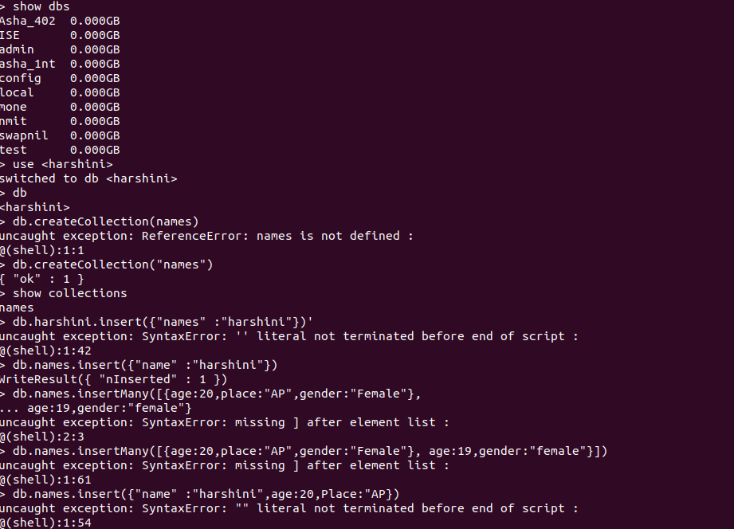

Now creating the database,if its already present then it will use that database otherwise it will create new database with that name.

use<harshini>

Using db command we can find the current database we are using.



To display the database name in show dbs atleast one value should be inserted..

If no values are present then that database will be deleted.

Creating a collection in the database:

db.createCollection(“names”)

To display the commands we use

Show collections



Inserting only one value into the collection

db.names.insert({“name” :“harshini”})

db.names.insert({“name” :“harshini”,“age”:20,“Place”:“AP”})



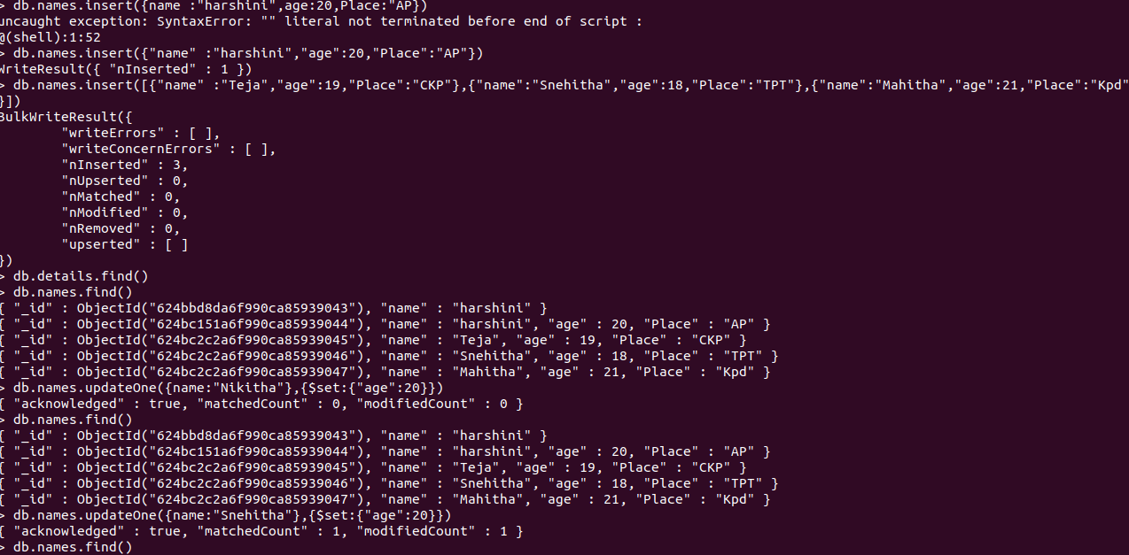

Inserting many values into the collection at once

db.names.insert([{“name” :“Teja”, “age”:19,“Place”:“CKP”},{“name” :“Snehitha”, “age”:18,“Place”:“TPT”},{“name” :“Mahitha”, “age”:21,“Place”:“Kpd”}])



To check the values present in the collection

db.names.find()



To update one value:

db.names.updateOne({name:“Snehitha”},{$set:{“age”:20}})

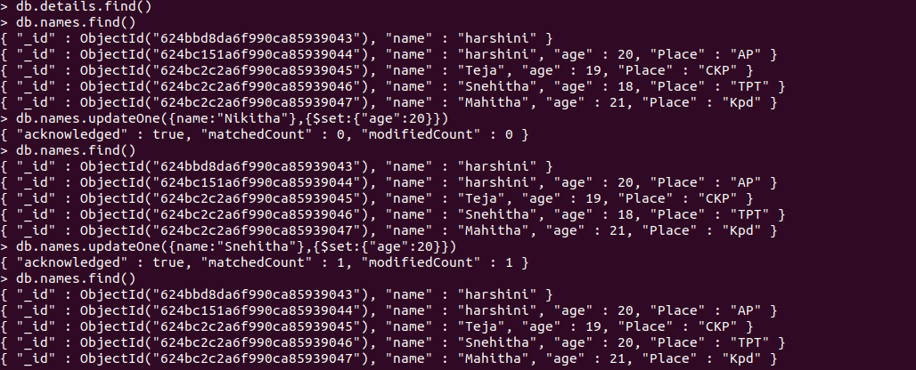

To check the updated value:

db.names.find()

